DATA MINING LAB-WEKA FILTERS

UNSUPERVISED:

INSTANCES:

NONE:

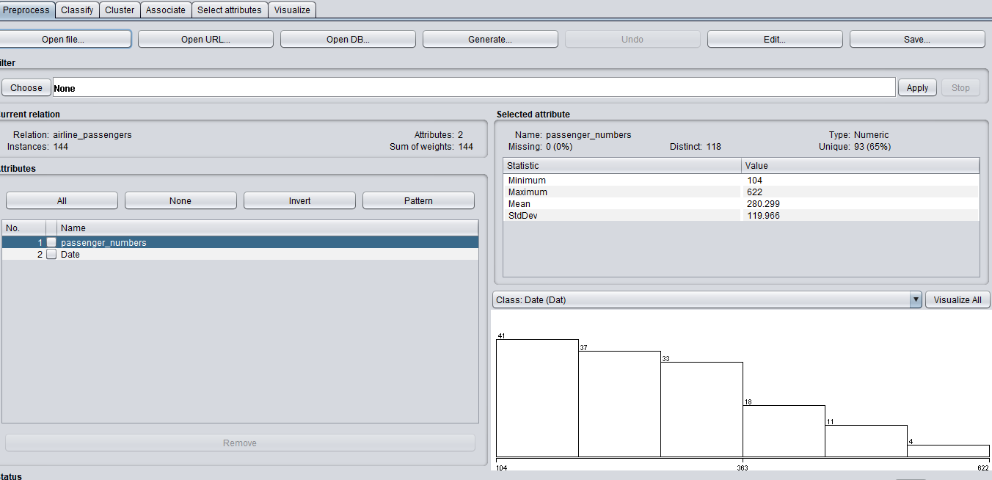

N UNNAMED:

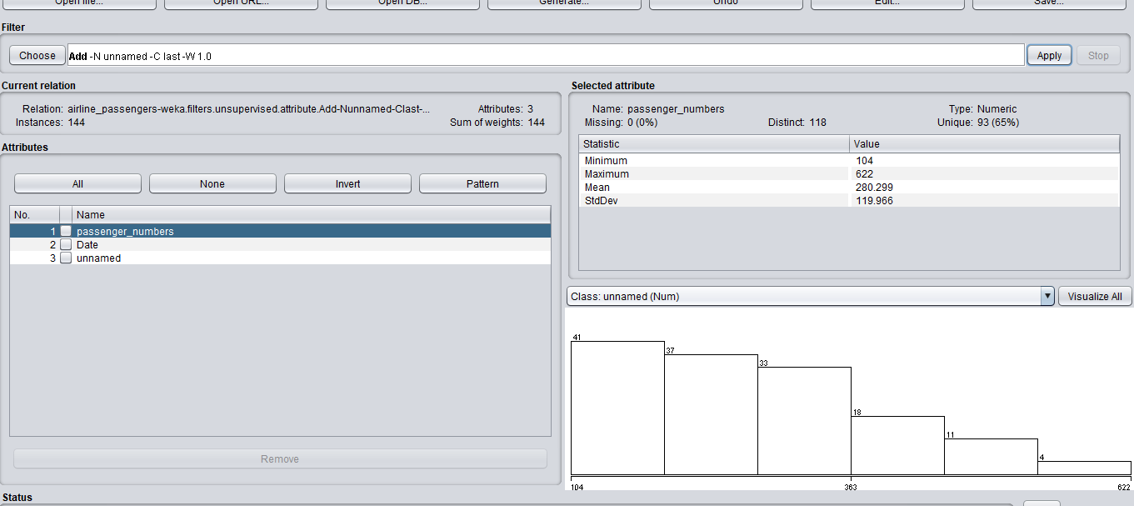

ATTRIBUTE:

ADD ID-Cfirst –N ID:

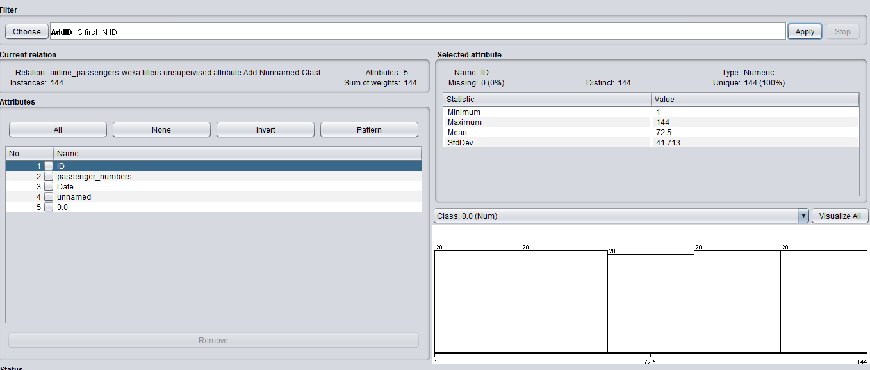

RESERVOIR SAMPLE:

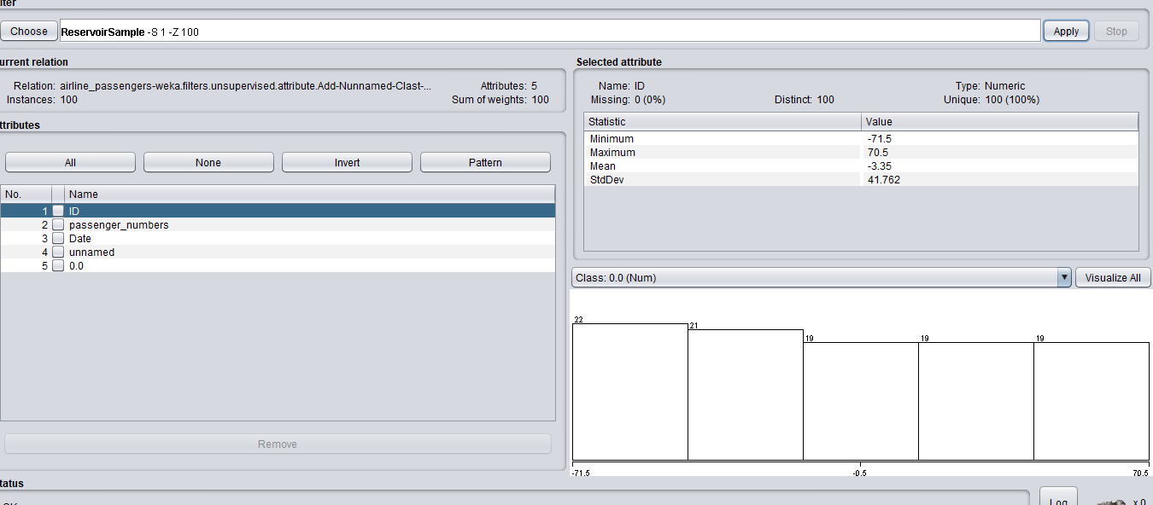

REMOVE RANGE:

